Red is the color of Communism……

There are very few who know what Obama's Czars do, as they quietly
go about their "work" in the nation's capital. This list of their names
and job descriptions should be educational to all Americans, no matter
what your political leanings.

See who they are and realize what they are fiercely dedicated to accomplishing:
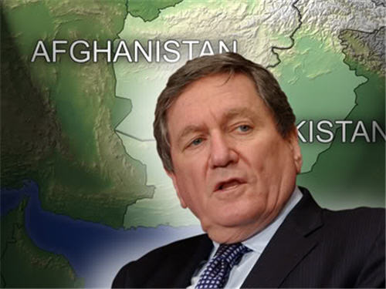
Richard Holbrooke - Afghanistan Czar
Ultra liberal anti-gun former Governor Of New Mexico.
Pro-Abortion and pro- drug legalization.
Wants to dissolve the 2nd Amendment
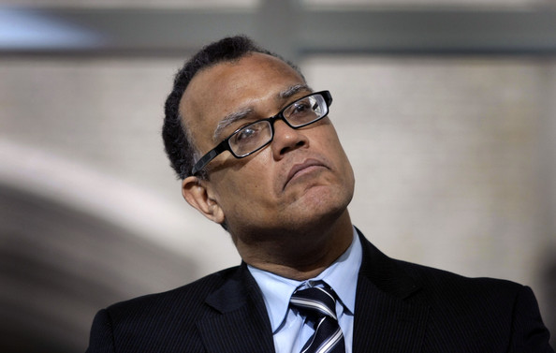

Ed Montgomery - Auto recovery Czar
Radical anti-business black activist.
Affirmative Action and Job Preference for blacks.

University of Maryland Business School Dean;

teaches that US business has caused world poverty.
ACORN board member. Communist DuBois Club member.
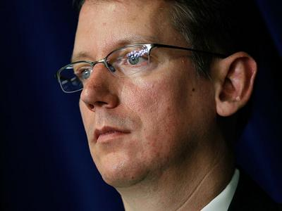

Jeffrey Crowley - AIDS Czar
Radical Homosexual. Gay Rights activist.
Believes in Gay Marriage and a Special Status for homosexuals only,
including complete free health care for gays.
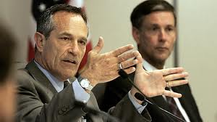

Alan Bersin - Border Czar
The former failed superintendent of San Diego.

Ultra-Liberal friend of Hillary Clinton.

Served as Border Czar under Janet Reno -
to keep borders open to illegals without interference from the Federal government.

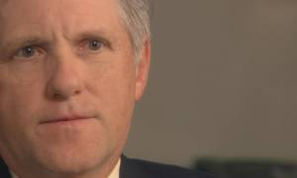

David J. Hayes - California Water Czar
Senior Fellow of radical environmentalist group "Progress Policy".
No training or experience in water management whatsoever.

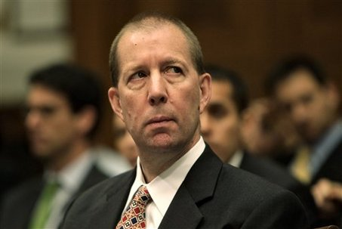

Ron Bloom - Car Czar
Auto Union worker. Anti- business & anti- nuclear.

Has worked hard to force US auto makers out of business.

Sits on the Board of Chrysler which is now Union-owned. How did this happen?
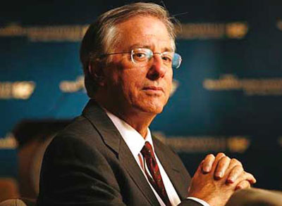

Dennis Ross - Central Region Czar
Believes US policy is the cause of war in the Middle East.

Obama apologist to the world. Anti-gun and completely Pro-Abortion.

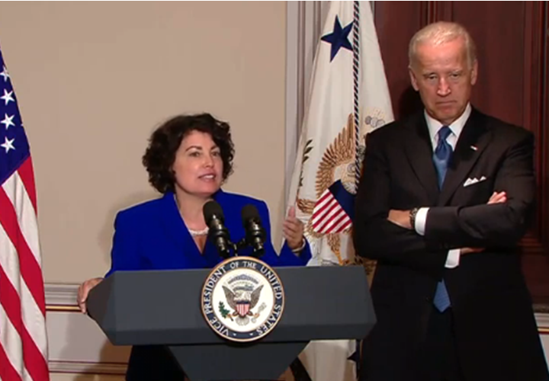

Lynn Rosenthal - Domestic Violence Czar
Director of the National Network to End Domestic Violence.
Vicious anti-male feminist. Supports male castration - imagine?
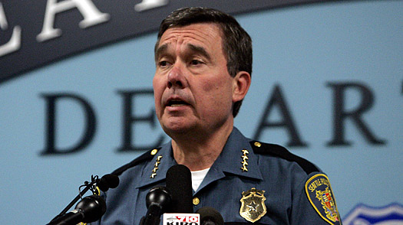

Gil Kerlikowske - Drug Czar
Devoted lobbyist for every restrictive gun law proposal,

former Chief of Police in liberal Seattle WA.

Believes no American should own a firearm.
Supports legalization of all drugs.

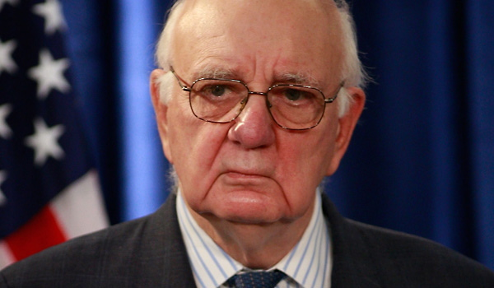
Paul Volcker - Economic Czar
Former head of the Federal Reserve under Jimmy Carter when US economy nearly failed.
Obama-appointed head of the Economic Recovery Advisory Board
which engineered the Obama economic disaster to US economy.
Member of anti-business "Progressive Policy" organization.
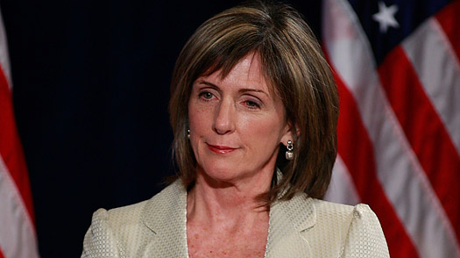
Carol Browner - Energy and Environment Czar
Political Radical. Former head of the EPA - known for anti-business activism.
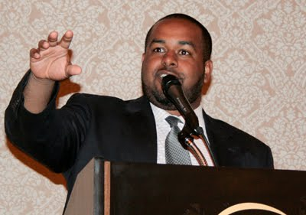
Strong anti-gun ownership.

Joshua DuBois - Faith-Based Czar
Political Black activist. Degree in Black Nationalism.
Anti-gun ownership lobbyist.
WHAT THE HELL DOES A FAITH BASED CZAR DO ? ? ?
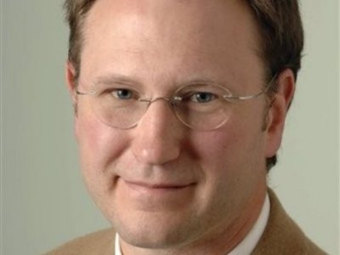

Cameron Davis - Great Lakes Czar
Chicago radical anti-business environmentalist.

Blames George Bush for "Poisoning the water that minorities have to drink."

No experience or training in water management whatsoever.
Former ACORN Board member (what does that tell us?)
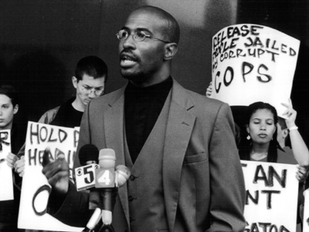

Van Jones - Green Jobs Czar (forced to resign).
Black activist with strong anti-white views.

Member of American Communist Party and San Francisco Communist Party.

Said George Bush caused the 9-11 attacks and wanted Bush investigated by the World Court for war crimes.

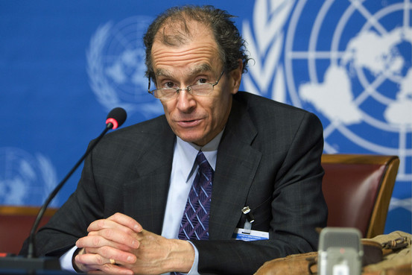
Daniel Fried - Guantanamo Closure Czar
Human Rights activist for Foreign Terrorists.

Believes America has caused the Global War on Terrorism.

Believes terrorists have rights above and beyond Americans.
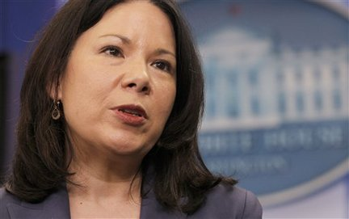

Nancy-Ann DeParle - Health Czar
Former head of Medicare / Medicaid.

Strong proponent of Healthcare Rationing (i.e. "Death Panels").

She is married to a reporter for The New York Times.
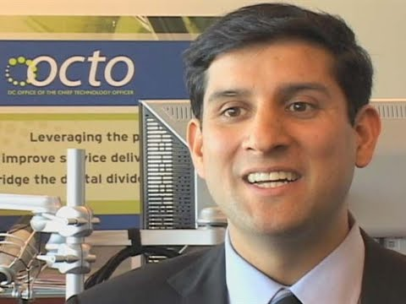

Vivek Kundra - Information Czar
Born in New Delhi, India. Controls all public information,

including labels and news releases.

Monitors all private Internet emails. (HELLO?)
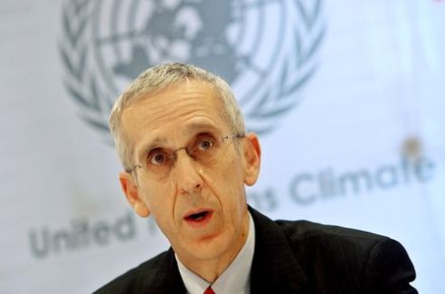

Todd Stern - International Climate Czar
Anti-business former White House Chief of Staff.

Strong supporter of the Kyoto Accord; pushing hard for Cap and Trade.

Blames US business for Global warming. Anti- US business prosperity.
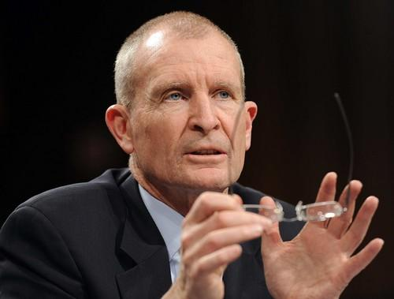

Dennis Blair - Intelligence Czar
Retired US Navy. Stopped US guided missile program he described as "provocative."
Chair of ultra-Liberal "Council on Foreign Relations"
which blames American organizations for regional wars.

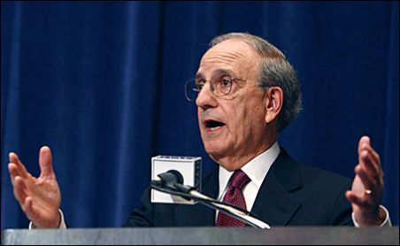
George Mitchell - Mideast Peace Czar
Fmr. Sen from Maine Left wing radical.
Has said Israel should be split up into "2 or 3" smaller more manageable plots." (God forbid)
A true Anti-nuclear anti-gun & pro homosexual "special rights" advocate.

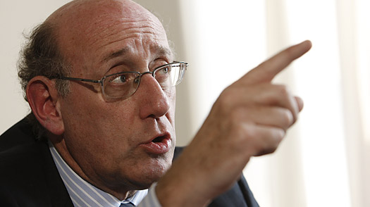

Kenneth Feinberg - Pay Czar
Chief of Staff to Ted Kennedy.
Lawyer who got rich off the 9-11 victims payoffs (horribly true).
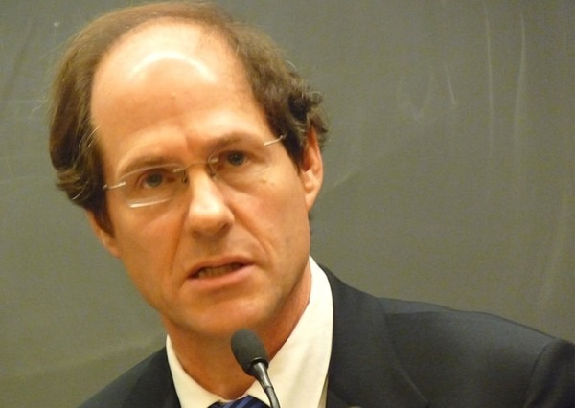

Cass Sunstein - Regulatory Czar
Liberal activist judge who believes free speech needs to be limited for the "common good";

essentially against the 1st Amendment.

Has ruled against personal freedoms many times on private gun ownership and right to free speech cases.
This guy has to be run out of Washington ! ! !
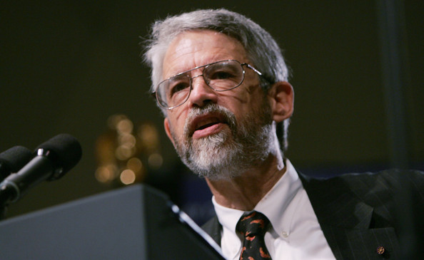

John Holdren - Science Czar
Fierce ideological environmentalist, Sierra Club anti-business activist.
Claims US business has caused world poverty. No Science training.
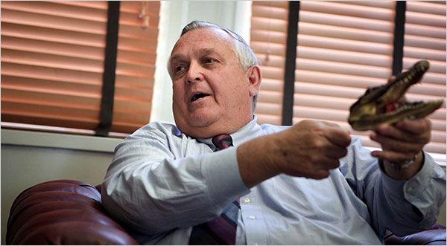

Earl Devaney - Stimulus Accountability Czar
Spent career trying to take guns away from American citizens.
Believes in Open Borders to Mexico.
Author of statement blaming US gun stores for drug war in Mexico.

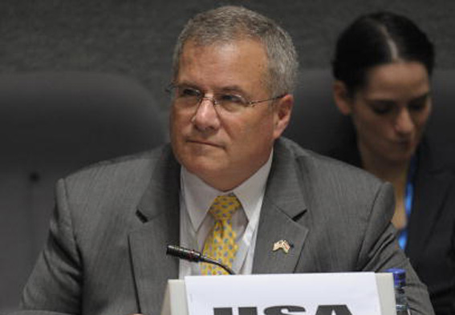

J. Scott Gration - Sudan Czar
Native of Democratic Republic of Congo.

Believes US does little to help Third World countries.

Council of foreign relations, asking for higher US taxes to support United Nations.
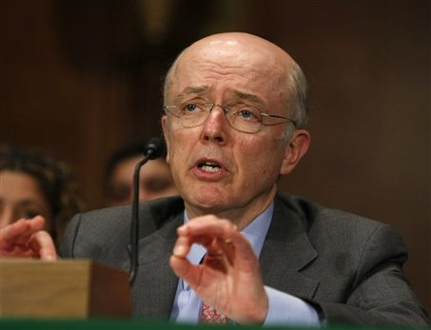

Herb Allison - TARP Czar
Fannie Mae CEO responsible for the US recession by using
real estate mortgages to back up the US stock market.
Caused millions of people to lose their life savings.

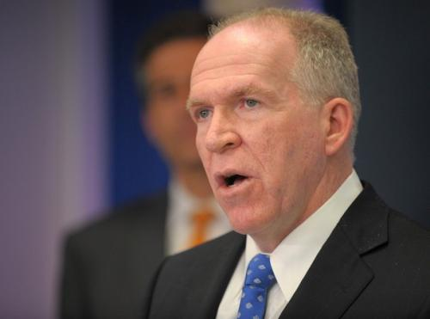

John Brennan - Terrorism Czar
Anti CIA activist. No training in diplomatic or gov. affairs.

Believes Open Borders to Mexico and a dialog with terrorists and has

suggested Obama disband US military! A TOTAL MORON!!!!
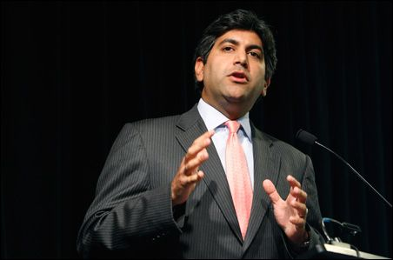

Aneesh Chopra - Technology Czar
No Technology training. Worked for the Advisory Board
Company, a health care think tank for hospitals.

Anti-doctor activist. Supports Obama Healthcare Rationing (i.e. Death Panels)

and salaried doctors working exclusively for the Government Healthcare plan.
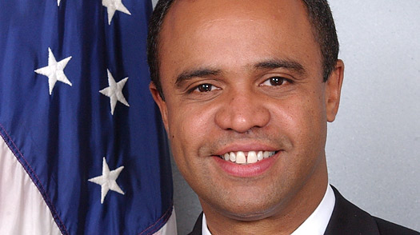

Adolfo Carrion Jr. - Urban Affairs Czar
Puerto Rico-born Anti-American activist and leftist group
member in Latin America. Millionaire "slum lord" of Bronx, NY.
Owns many lavish homes and condos which he got from "sweetheart" deals with labor unions.
Wants higher taxes on middle class to pay for minority housing and healthcare.
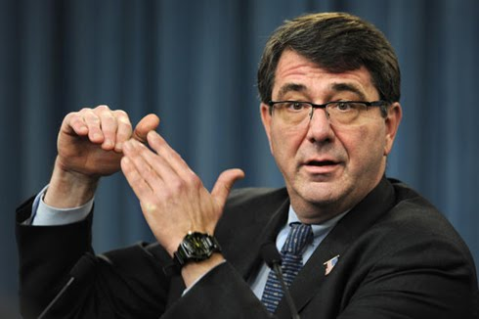

Ashton Carter - Weapons Czar
Leftist. Wants all private weapons in US destroyed.
Supports UN ban on firearms ownership in America. No Other "policy".
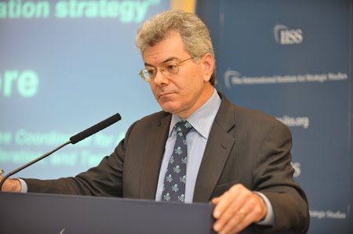

Gary Samore - WMD Policy Czar
Former US Communist.
Wants US to destroy all WMD (Weapons of Mass Destruction) unilaterally as a show of good faith.
Has no other "policy"

These are the people who are helping President Obama run our country.

